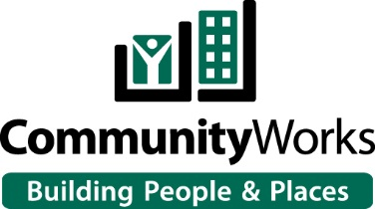

Thank you for your interest in obtaining a PPP loan through CommunityWorks. In order to streamline the process, we have set up an online system for applications going forward.
Attached you will find the following documents:
- Instructions on how to use the online application system.
- A calculation form to assist you in calculating your payroll costs and eligible loan amount.
We suggest that you review the instructions and complete the calculation form before starting the application process.
The basic rules for calculating payroll are as follows:
- For a Sole Proprietorship, an Independent Contractor or an LLC that files a Schedule C on their personal tax return, you will need to use line 31 of your 2019 Schedule C and enter that amount on line C6 of the calculation form.

- For a Corporation, S-Corp or other entity that has W-2 employees, you will need to use your quarterly 941 reports and place the quarterly gross payroll figures from line 2 and place the figures on lines C5, F5, I5 and L5.

- Wages you pay to a contact employee that are reported on a 1099 are not eligible for the PPP loan program. Those who receive a 1099 may apply for their own PPP loan after they have filed their 2019 taxes and Schedule C.

- If you have further questions on how to complete the calculation form, please email Paul Schmitt at pschmitt@cwcarolina.org for assistance.

When you have reviewed the instructions and completed the calculation form, please visit:
https://cwcarolina.venturesgo.com/portal/borrowerapplication/
and follow the instructions. Make sure you answer all questions completely and that you upload the necessary documents when prompted. Once your application is received, someone from CommunityWorks will reach out to you to complete the process.
The deadline for applications is August 5, 2020 to allow us time to submit all applications by the SBA deadline.
We look forward to assisting you with this process.

